IBM CAPSTONE PROJECT

**FINDING THE RIGHT PLACE TO VISIT WHEN TRAVELLING AND ADDRESSING THE CHANGING TRAVELLING INTEREST OF TRAVELLERS**

By –

Alan Paul Jaxon

1. **Introduction**

Many people are finding it difficult to find the right place to visit when they are in traveling around the globe. Most importantly it is the travel guides and navigators who are adversely affected while venturing into new territories due to lack of knowledge about the place and places where they could go. To get the full enjoyment and understanding of a journey and its places the major attractions have to be seen, felt, and understood. Currently, even though many apps and software are available for fulfilling this purpose, this program on python focuses on some simple solutions to the people. Usually, just details of these places are provided, and a map of such places that can be interacted with is not available. This project addresses this issue also.

#Note - not just popular tourist place, but the place to dine, motels, shopping will also be shown

1. **Data**

As required for every purpose data is very important. It is one of the most vital parts of any process. So for the data required we will be finding our required data using foursquare API. It will be able to provide us with the necessary information required to find the popular places. For the purpose of doing the project, we will select Kochi a city in Kerala (India).

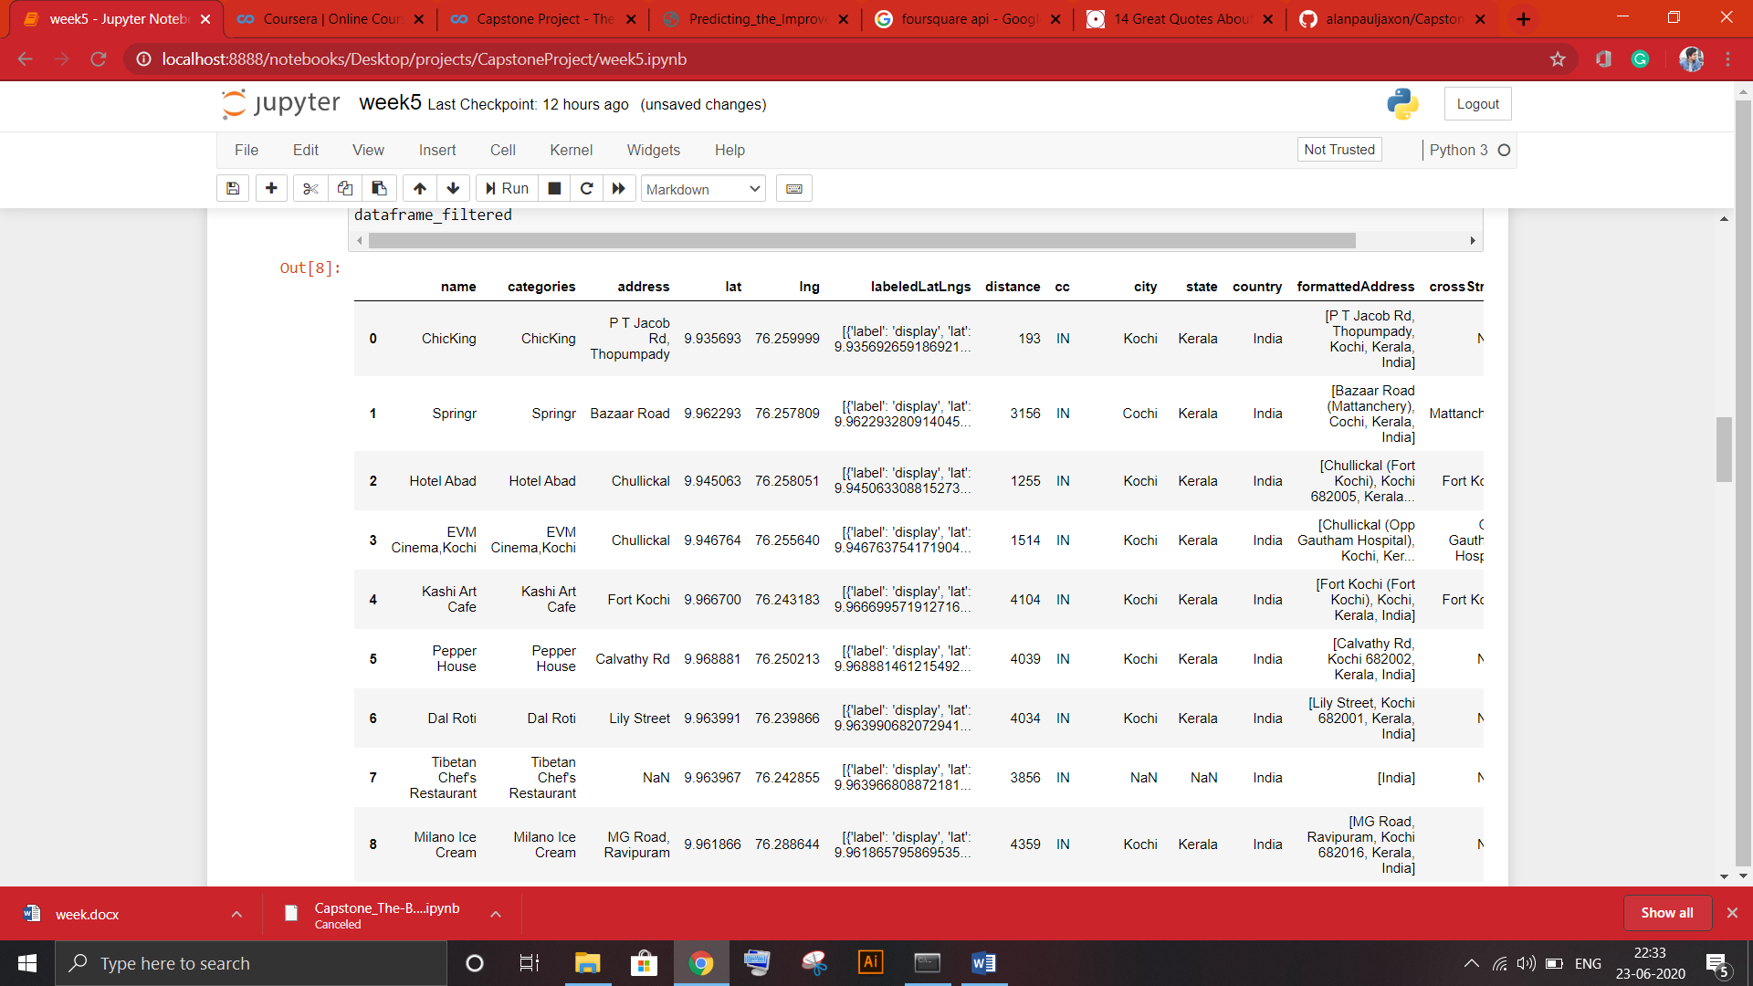

Figure 1: A part of the data set from the foursquare API

1. **Methodology**

The purpose of this report is to find if the codes will be able to provide the best places to visit (food, hotel, restaurants, tourist place, etc.). For this purpose, we will be first making use of the foursquare API to gather data regarding the popular place in a location.

For this, an account in foursquare API was created. Foursquare is a social location service that allows users to explore the world around them. Users can download the Foursquare application to their iPhone, Blackberry, or Android phone and sign up for free, then connect their Foursquare accounts to their other social media accounts. This forms the data on which we will be working on.

After this, with the help of folium, these locations were marked on the map. the specialty of the map is it can be interacted with. One can zoom in and out, click on the points, etc.

The point in red will be the main area, and the point in blue will be an interesting area in the stated region. the radius can be adjusted by changing the value of the radius.

1. **Result**

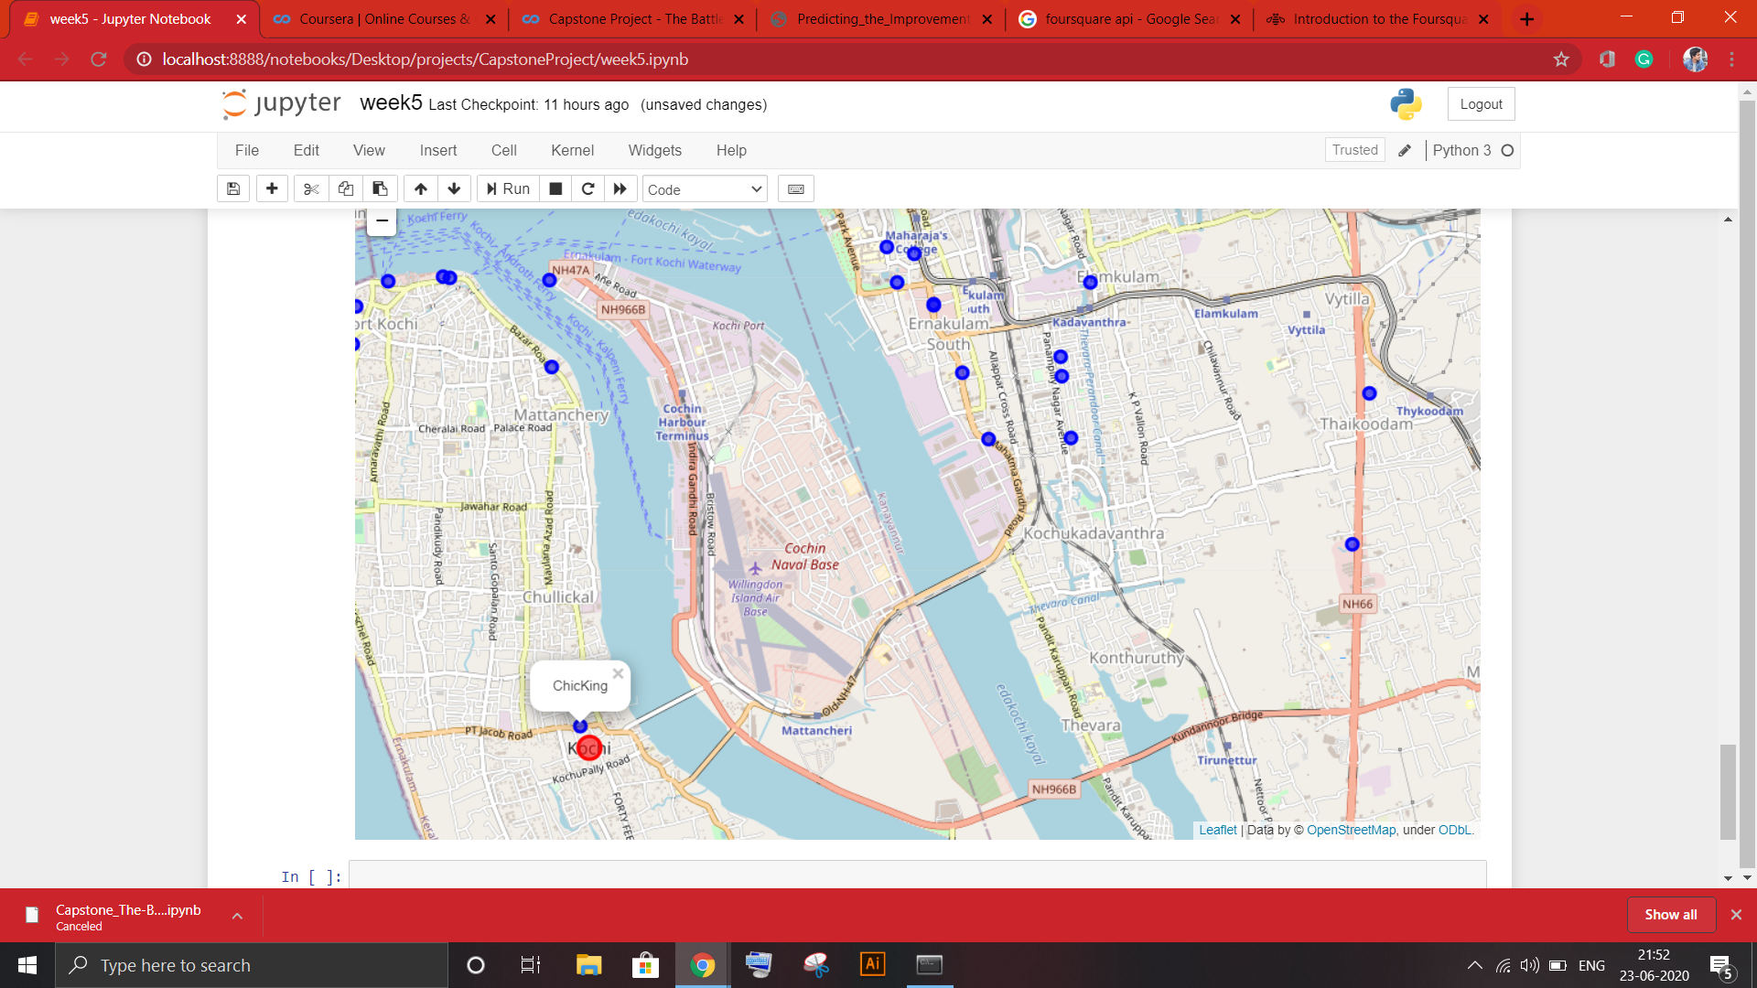

Figure 2: This is the result we generated through our code

1. **Discussion**

From our project, we were able to understand that currently there are 30 interesting places when Kochi is set as us our location and radius is set to 5000. This is very useful even when the location of the radius within which the search is to be done varies. On testing it with the radius as 500, the result was only 7. This shows how the result varies as a single value is changed. as the city or state or country is changed the data generated as well as folium produced is also changed. Only the value of the place has to be changed. No other data has to be mingled with. Thus python provides a quick result by just a click of hands.

The main limitation of this is that getting the direction is a very difficult task when compared to google maps and other similar apps and also producing the image of the place has been ignored. But including various more code, we will be able to include such functions also.

While considering the future study we can also include the above-mentioned items to generate much sophisticated and interactive code and output.

1. **Conclusion**

Through this, we understood how powerful and simple the use of python can make various problems faced by people in the modern era. Here I would like to quote the words of Guido van Rossum -

‘The joy of coding Python should be in seeing short, concise, readable classes that express a lot of action in a small amount of clear code -- not in reams of trivial code that bores the reader to death’

The more we understand the language more beautiful it becomes. Deeping the knowledge will provide us with wide tools and libraries of python we can use to solve various problems